**User protocol: Barcoding with Opentrons Flex**

|  |  |  |  |
| --- | --- | --- | --- |
| **A** | 50µl  pipette tips | Barcode plate | Trash |
| **B** |  | Saponin block | 1000µl  pipette tips |
| **C** | Falcon tubes  (A5/B5) | Cells  block | PBS/Saponin reservoir (160mL) |
| **D** | 1000µl  pipette tips | CSM reservoir (260mL) | PBS reservoir (110mL) |
|  | **1** | **2** | **3** |

**Overall layout:**

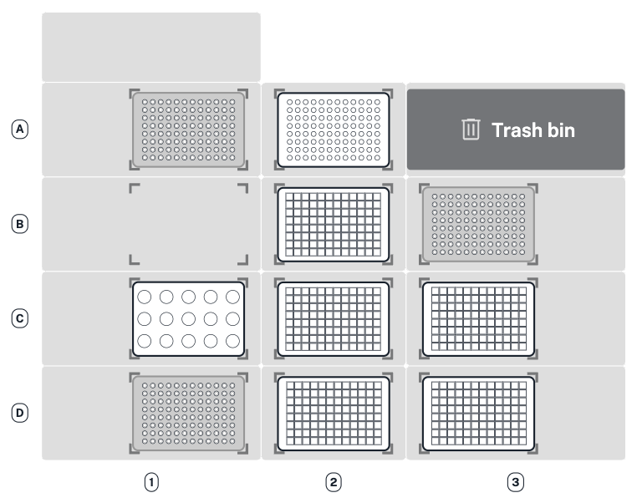

**Volumes listed in this protocol are calculated for 96 wells. Robot will display volumes at the beginning of the run if handling less than 96 samples.**

**Preparations:**

* **A2:** Add 96 well barcode plate (Pt/Pd/Au) with at least 5µl of barcode reagent.
* **B2:** Add empty deepwell (saponin) block.
* **C1:** Add empty 15ml Falcon tubes on A5/B5 positions.
* **C3:** Add 160mL of 0.02% PBS/Saponin (1.6mL of 2% Saponin aliquot + 158.5mL PBS).
* **D2:** Add 260mL of CSM.
* **D3:** Add 110mL of PBS.

|  |
| --- |
| Robotic: 5 min. **PBS wash**. Final volume per well: 1000µl |

Spin at 600xg for 5 min at RT. During spin continue with:

|  |
| --- |
| Robotic: 5 min. **Distribute saponin** (450µl per well) to saponin block. Final volume per well: 195µl |

Aspirate supernatant, vortex to loosen cell pellet, and return cell block to C2.

|  |
| --- |
| Robotic: 5 min. **PBS/Saponin wash**. Final volume per well: 1000µl |

Spin at 600xg for 5 min at RT. During spin continue with:

|  |
| --- |
| Robotic: 5 min. **Distribute saponin** (450µl per well) to saponin block. Final volume per well: 195µl |

Aspirate supernatant, vortex to loosen cell pellet, and return cell block to C2.

|  |
| --- |
| Robotic: 25 min. **Barcode cells,** incubation, **first CSM wash.**  Final volume per well: 1000µl |

Spin at 600xg for 5 min at RT, aspirate supernatant, vortex to loosen cell pellet, and return cell block to C2.

|  |
| --- |
| Robotic: 5 min. **Second CSM wash**. Final volume per well: 1000µl. |

Spin at 600xg for 5 min at RT, aspirate supernatant, vortex to loosen cell pellet, and return cell block to C2.

|  |
| --- |
| Robotic: 5 min. **Third CSM wash**. Final volume per well: 1000µl. |

Spin at 600xg for 5 min at RT, aspirate supernatant, vortex to loosen cell pellet, and return cell block to C2.

|  |
| --- |
| Robotic: 10 min. **First pooling, washing wells with CSM, second pooling**. |

Spin the two 15mL Falcon tubes at 600xg for 5 min at RT, aspirate supernatant, vortex to loosen cell pellet.

Filter the cells through a cell strainer FACS tube and count cells, then freeze in 40M aliquots.